I am working on troubleshooting an error which I am getting after selecting “Start Training” on the Flask site. It is a FileNotFound error that states, “No such file or directory: 'uploads/uploads/ETTh2.csv'” which is strange because it is referencing an incorrect file path. This is also particularly strange because I added some print statements into my code for debugging purposes, all of which indicate that the uploaded file is saved to the right path: uploads/ETTh2.csv. I addressed the previous FileNotFoundError which read, “No such file or directory: 'uploads/ETTh2.csv'” by making some modifications to the code, so I’m going to retrace my steps and see what changes could have led to this new, yet similar and strange error. I have not reached out to a grad student for assistance yet, as my thinking was that this error is very specific to my site’s .py file and not related to the OFA model, so it may be best for me to continue troubleshooting.

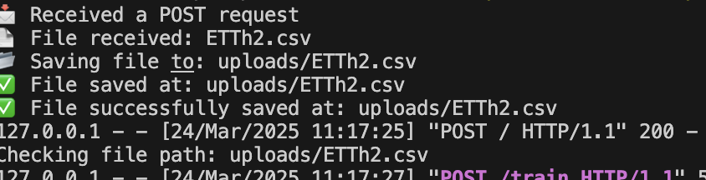



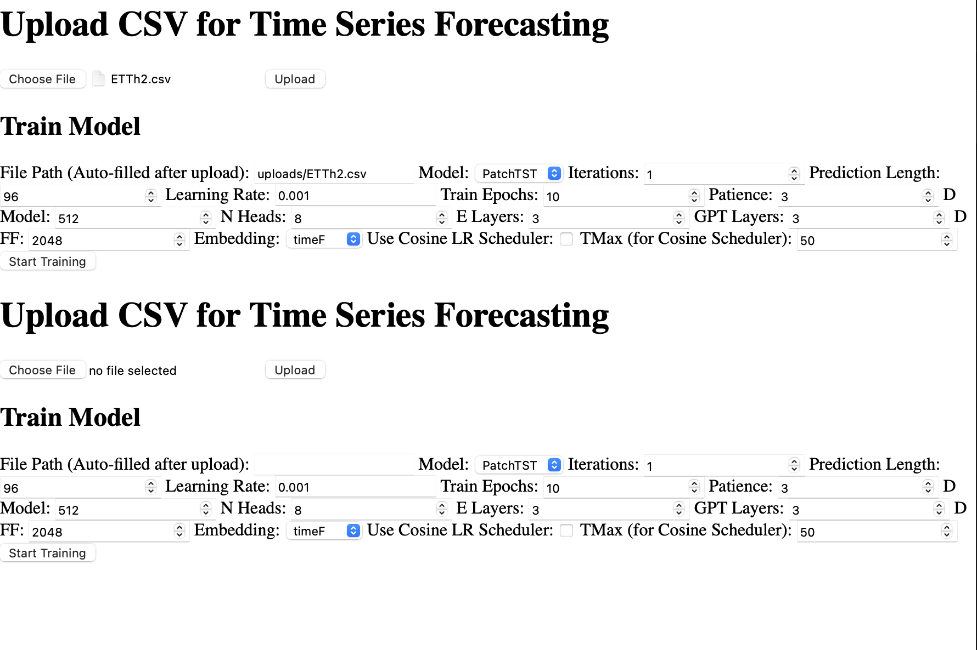

\*Update: I fixed the error by fixing a path duplication in the train endpoint and now have a new error: TypeError: cannot do slice indexing on RangeIndex with these indexers [454.0] of type float” There is probably a spot in the data loader file that is using floating points for indexing purposes.